**DAILY ONLINE ACTIVITIES SUMMARY**

|  |  |  |  |  |  |  |  |
| --- | --- | --- | --- | --- | --- | --- | --- |
| **Date:** | | **4/6/2020** | | | | | |
| **Name of the Faculty** | | **REENA LOBO** | | | | | |
| **No. of Students Allotted for monitoring** | | | | | **19** | | |
| **Progress** | | | | | **GOOD** | | |
| **Whether collected report from all the allotted students** | | | | | **15,NOT SUBMITTED RAMITHA, PRAVEEN KUMAR,RAGHAVI,SACHIN** | | |
| **Online Test Summary** | | | | | | | |
| **Subject** | **OPERATING SYSTEM** | | | | | | |
| **Semester** | **6** | | | **Duration** | | **40MIN** | |
| **No. of students Taken** | | | **108** | **Passing %** | | **88** | |
| **Certification Course Summary** | | | | | | | |
| **Course** | | Attended **Webinar:** **Digital Marketing - An overview and its Effectiveness for Educational Institutions**  **Certification provider:** **ACS COLLEGE OF ENGINEERING**  **Duration:2hr.**  **2.participated in TECHNOLOGICAL AND DIGITAL TRANSFORMATION QUIZ**  **CERTIFICATION PROVIDER:SMVIT COLLEGE** | | | | | |
| **Certificate Provider** | |  | | | **Duration** | |  |
| **Coding Challenges** | | | | | | | |
| **Problem statement: Write a code segment in java to swap two numbers using call by object reference.**  **Language used for solving: JAVA**  **Whether posted in Github: YES**  **Link:** <https://github.com/orgs/alvas-education-foundation/teams/2nd-year/discussions/98>  **How many students attempted :33** | | | | | | | |
| **Status: COMPLETED** | | | | | | | |
| **Uploaded the report in Github** | | | | | **yes** | | |
| **If yes Repository name** | | | | | <https://github.com/reenalobo/ONLINE-ACTIVITY-REPORT/upload/master> | | |
| **Uploaded the report in slack** | | | | | **yes** | | |

Certification Course Details: (Attach the snapshot and briefly write the report for the same)

Attended **Webinar:** **Digital Marketing - An overview and its Effectiveness for Educational Institutions**

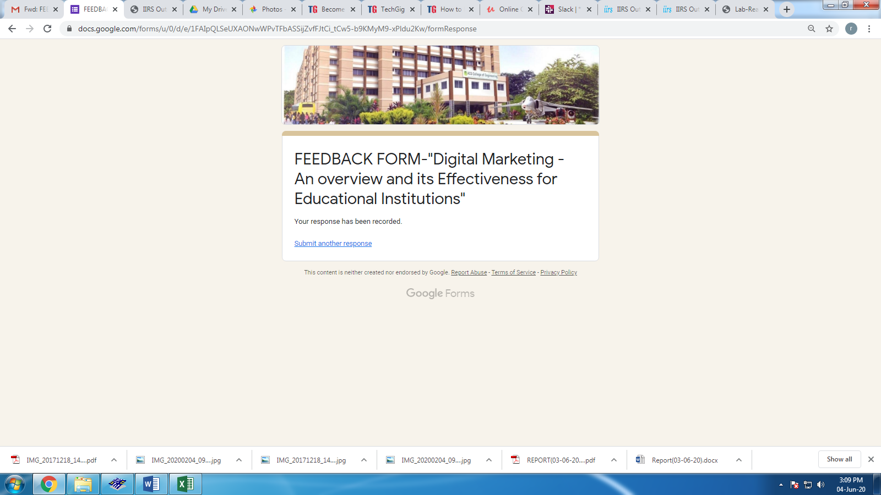

**CODING CHALLENGE:**

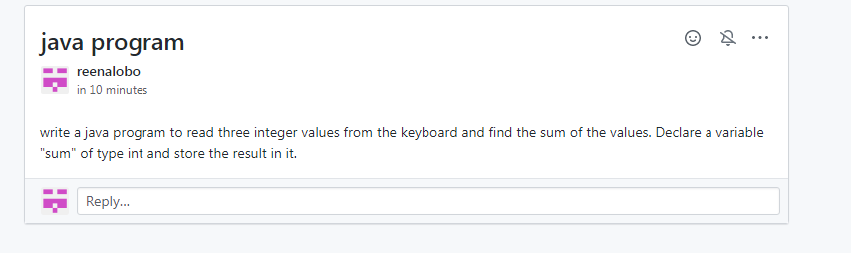

**ONLINE TEST:**

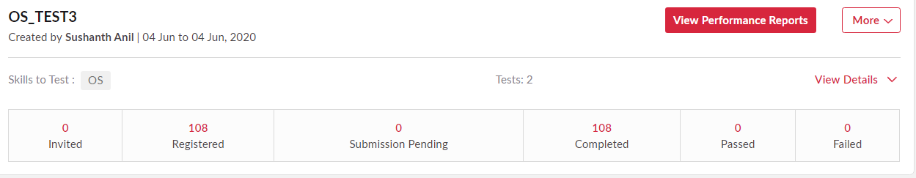

STUDENTS REPORT:

RAVALI:

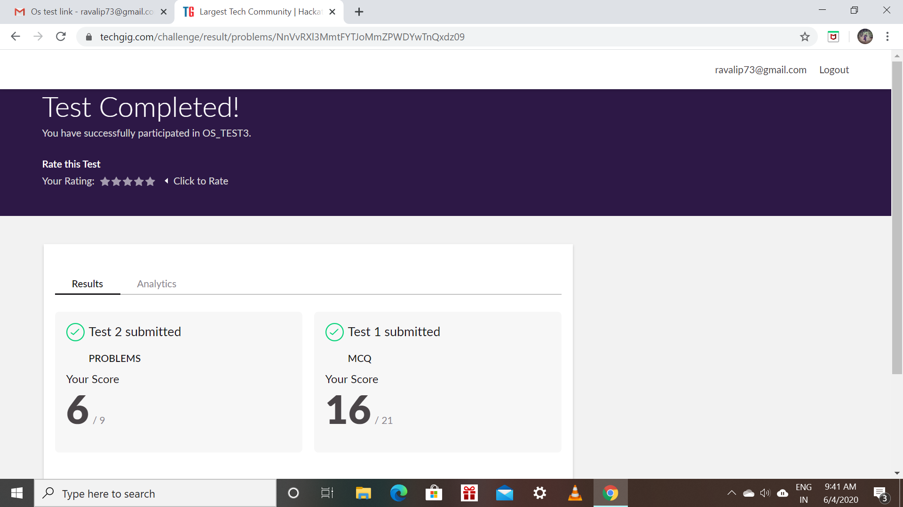

RAKSHA:

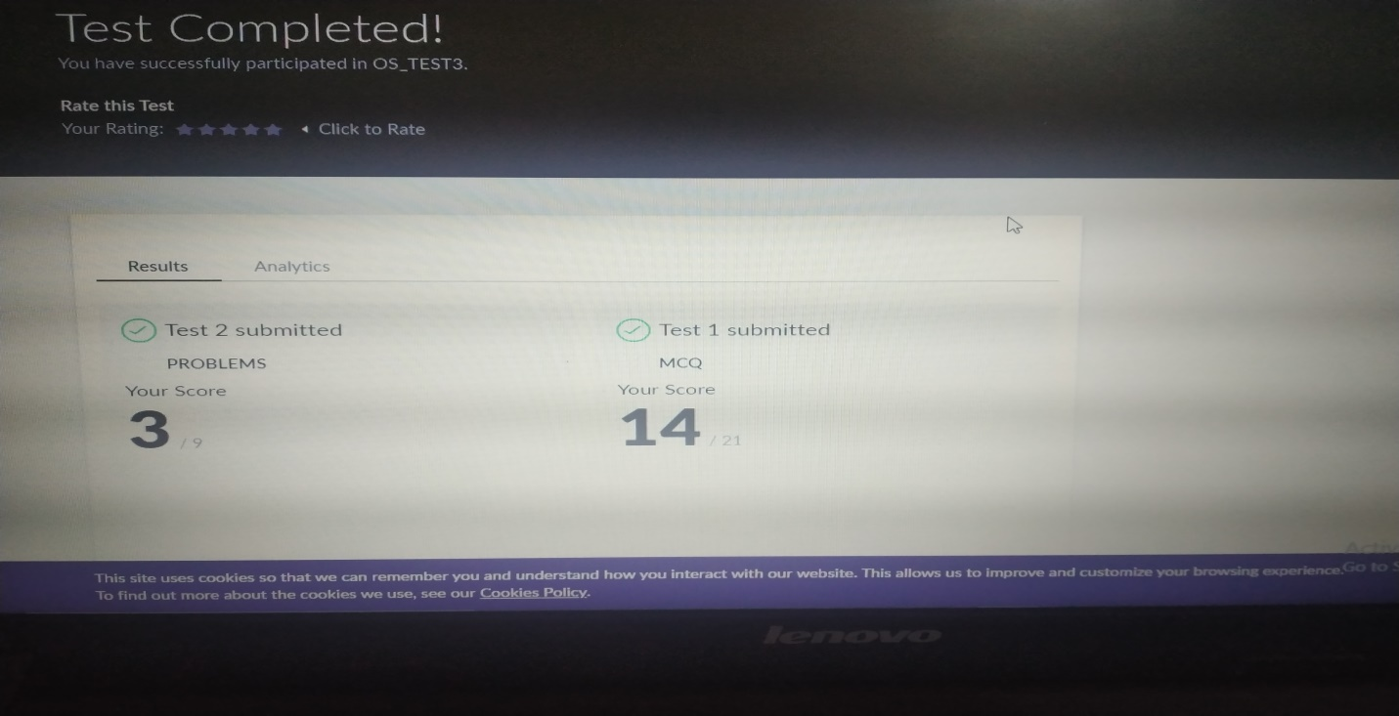

Scored 17 out of 30 in Python Assignment test

Certification Course Details:

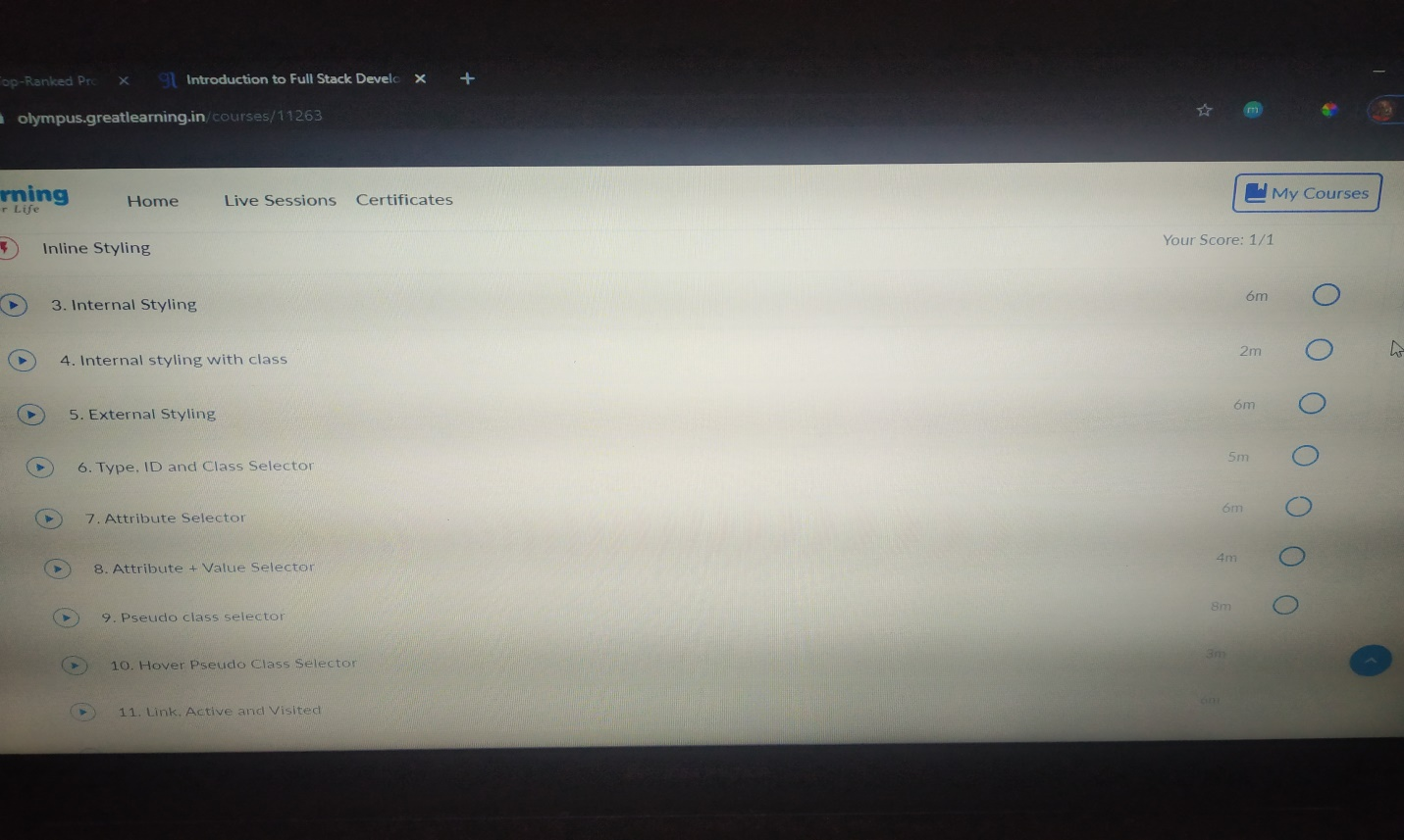

ROHAN MAHAVEER:

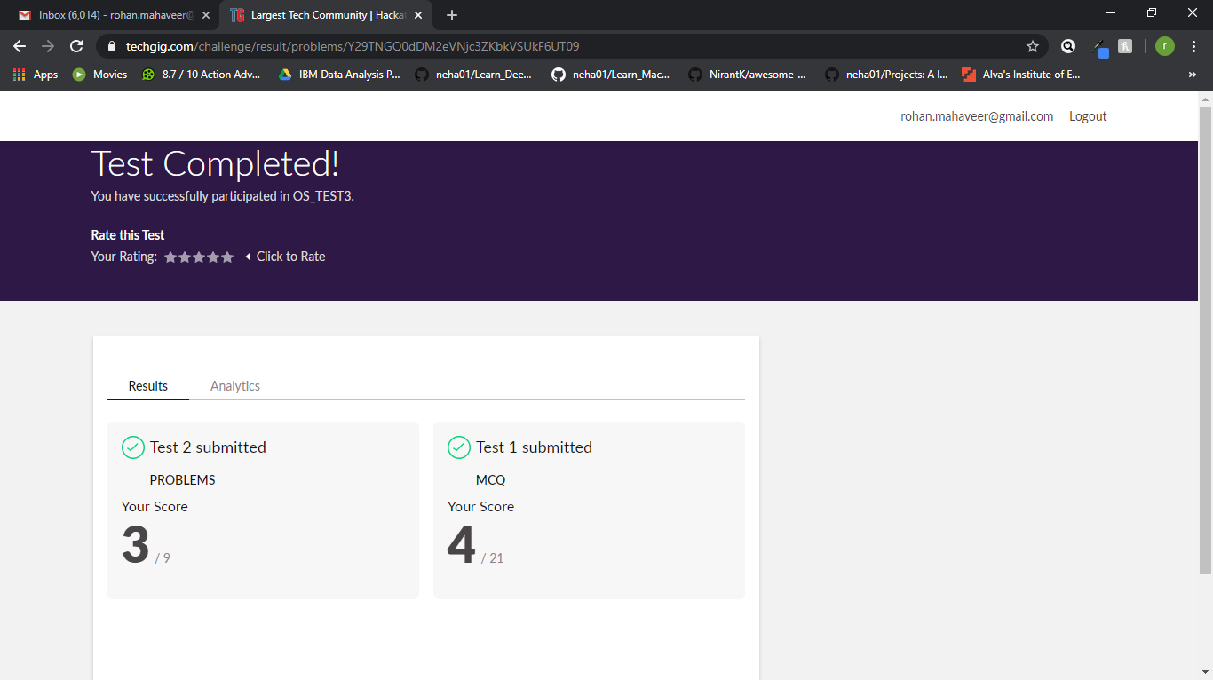

Scored 07 out of 30 in Python Assignment test

Certification Course Details:

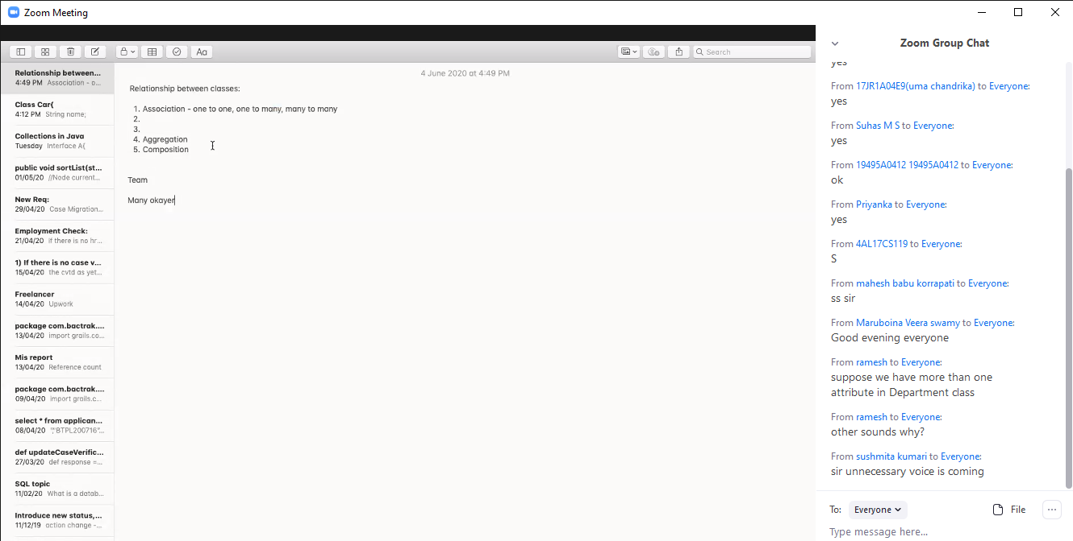

PREETHI

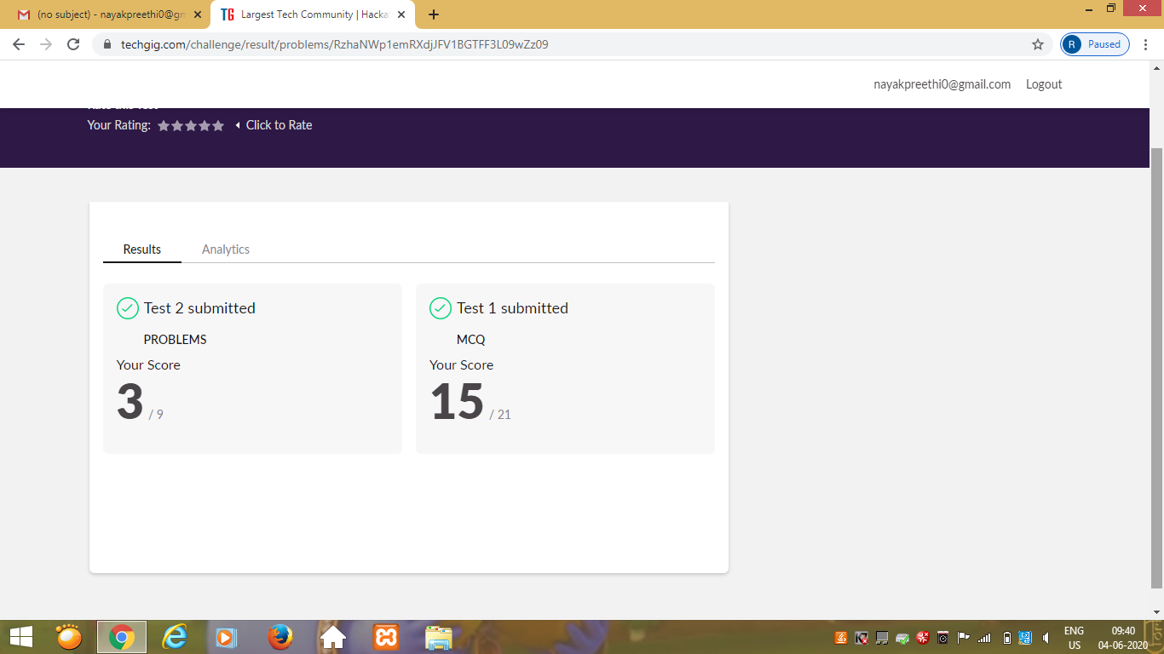

Certification Course Details: (Attach the snapshot and briefly write the report for the same)

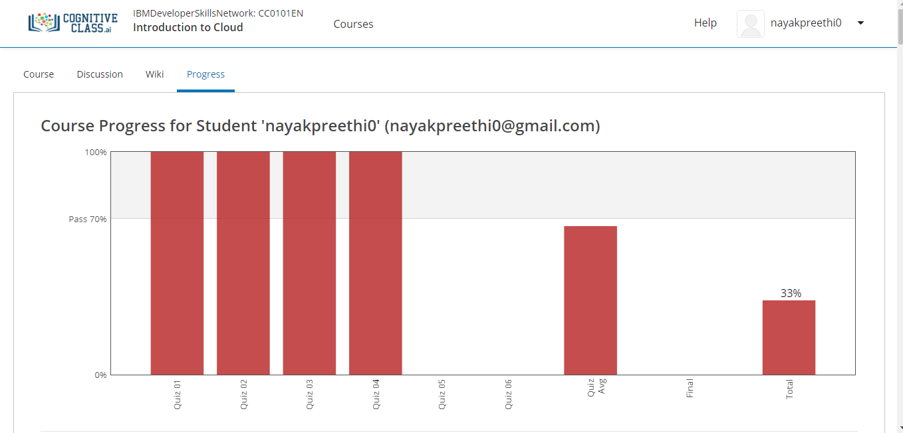

PRANAV:

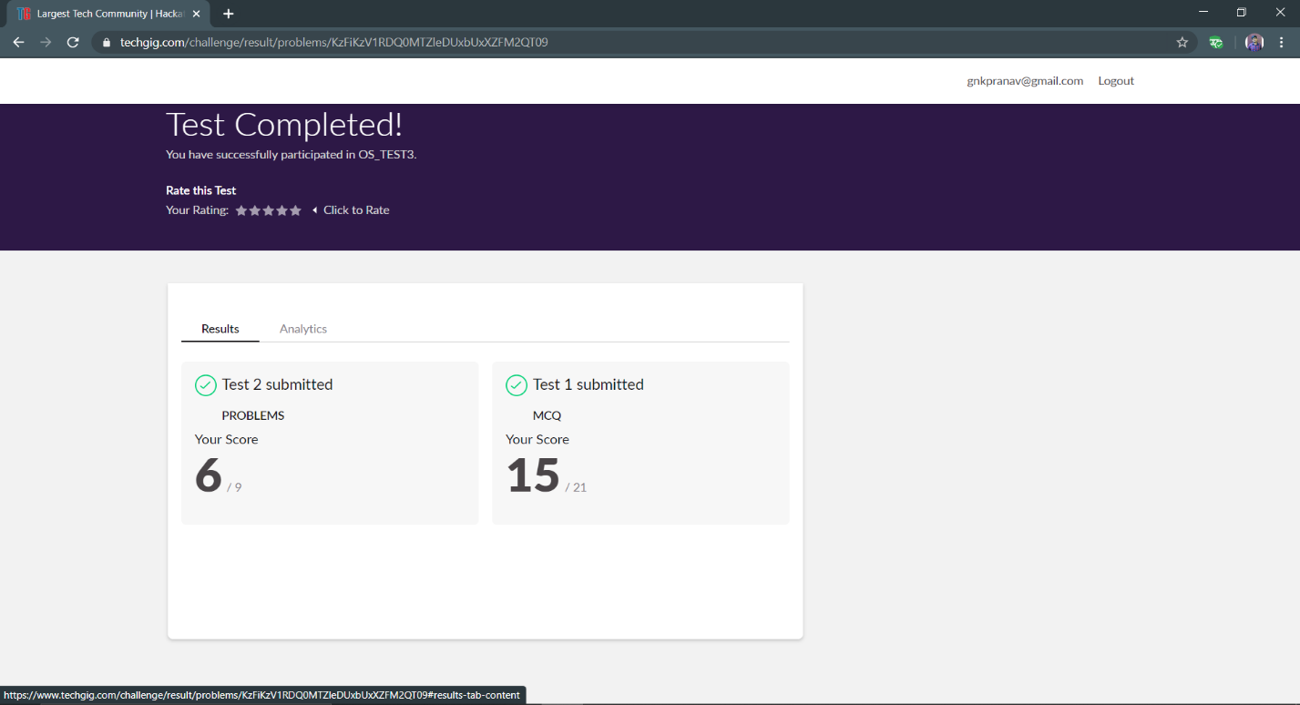

CERTIFICATION DETAILS

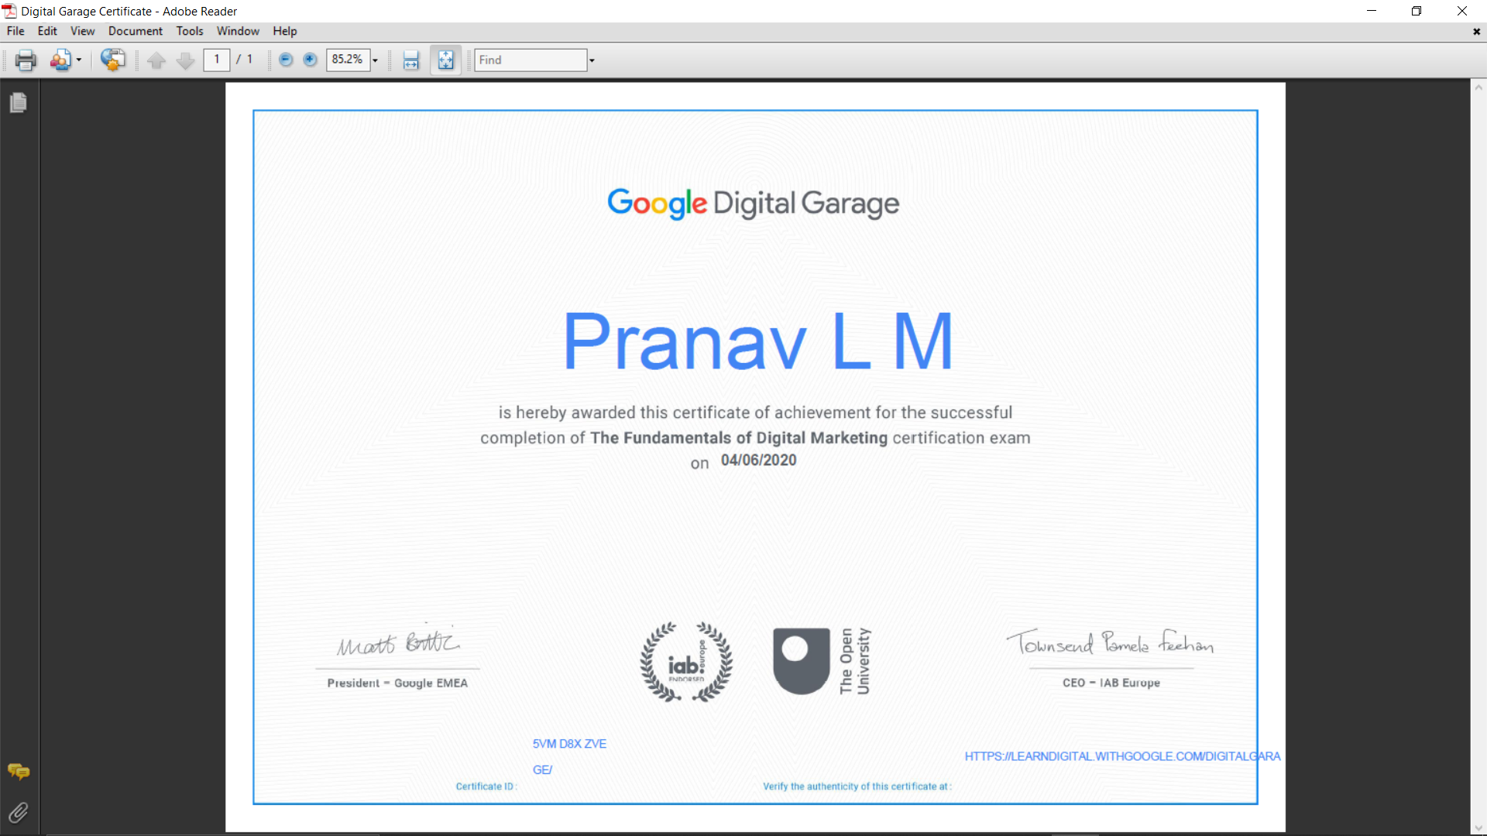

RANI:

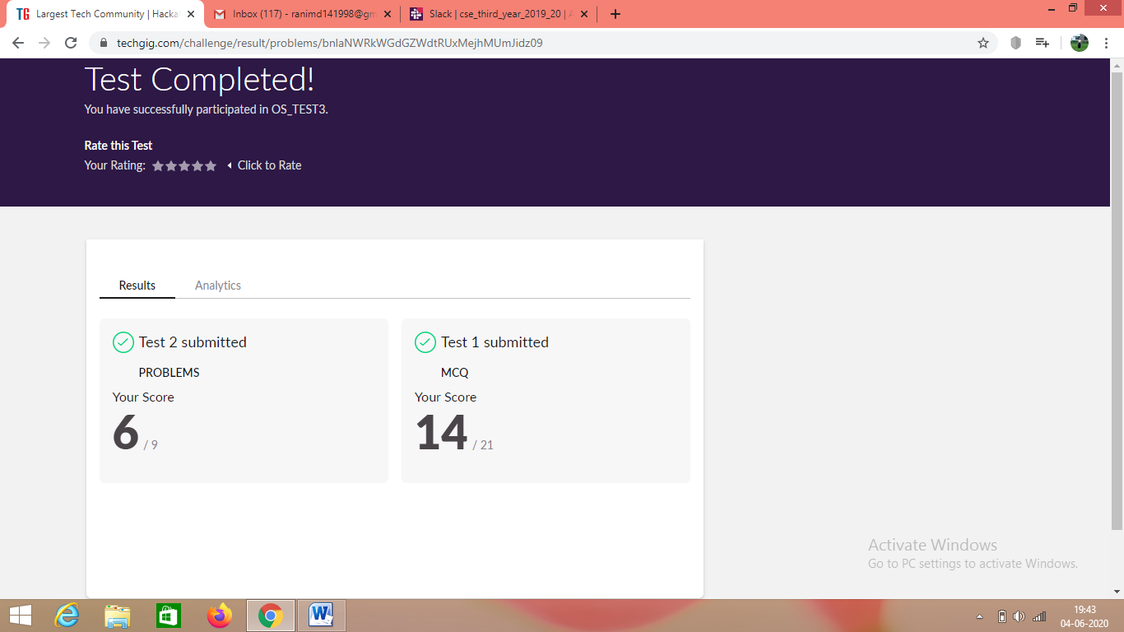

Certification Course Details: (Attach the snapshot and briefly write the report for the same)

­­

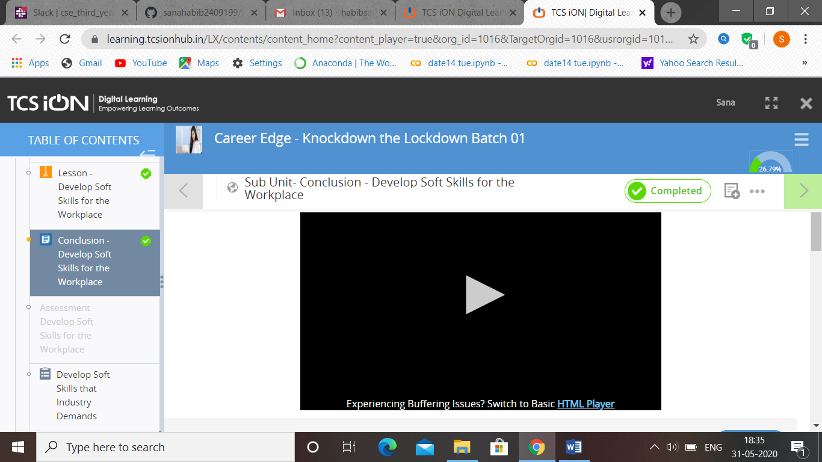

RACHANA:

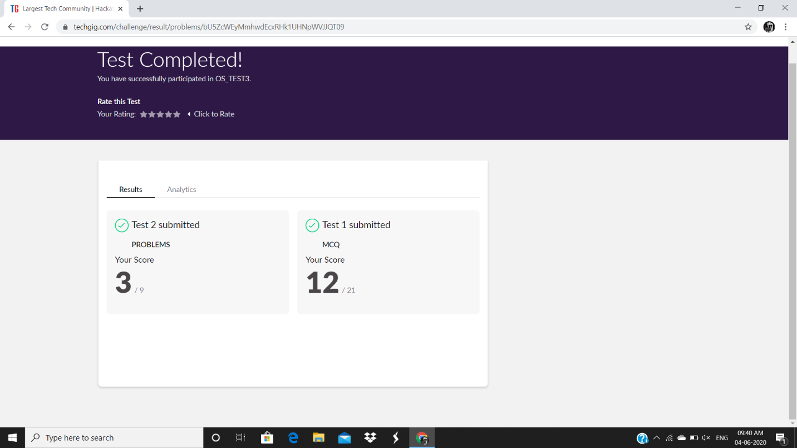

**Certification Course Details:**

**Today Progress: Course Summary**

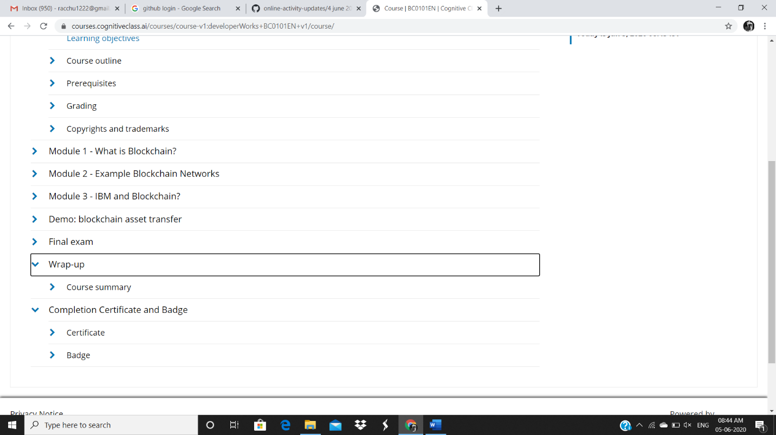

PRIYANKA:

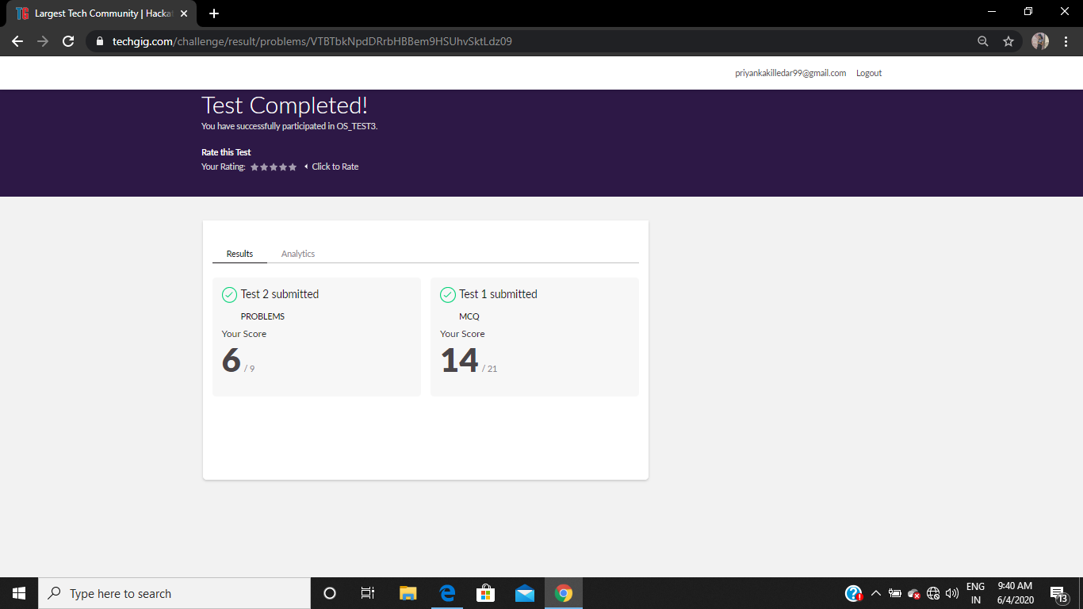

**Certification Course Details:**

**E-Box Classes:**

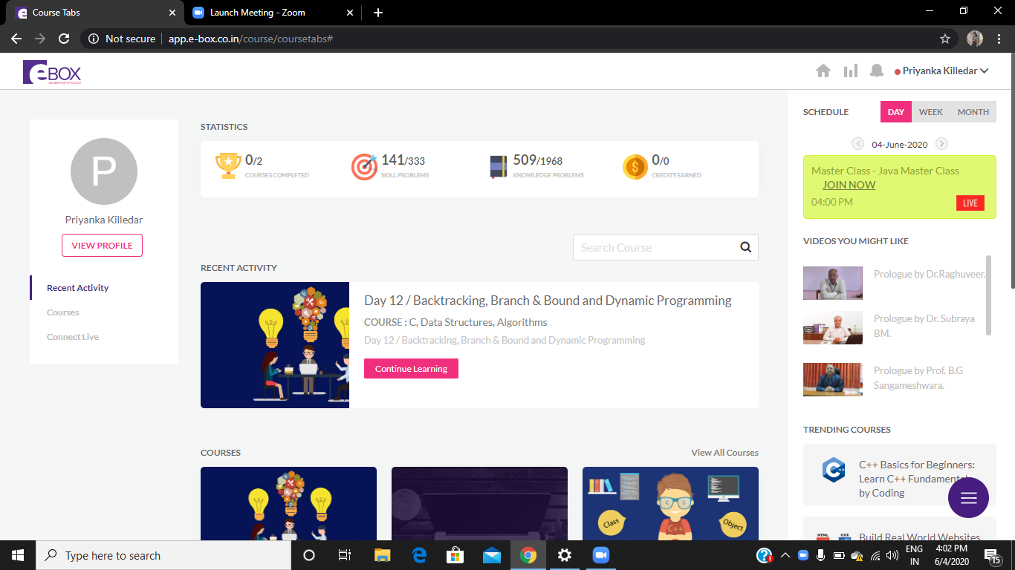

SANA:

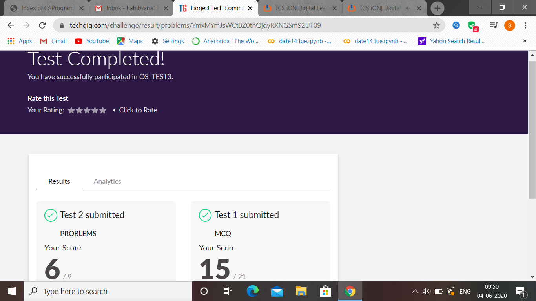

OS test 3 was held today. i.e 4 June 2020. Out of 30 marks I scored 21.

Certification Course Details: (Attach the snapshot and briefly write the report for the same

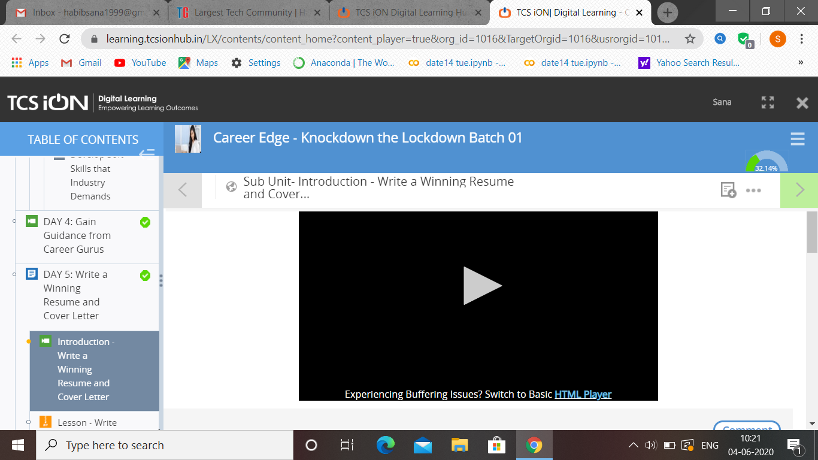

SHANBHAG:

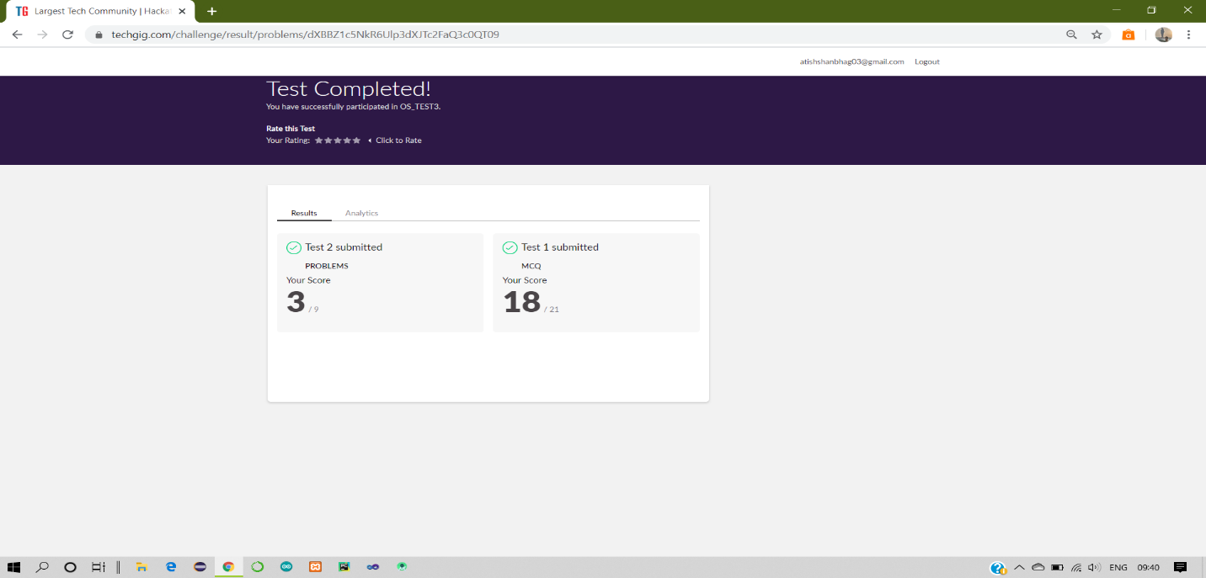

Certification Course Details:

Report

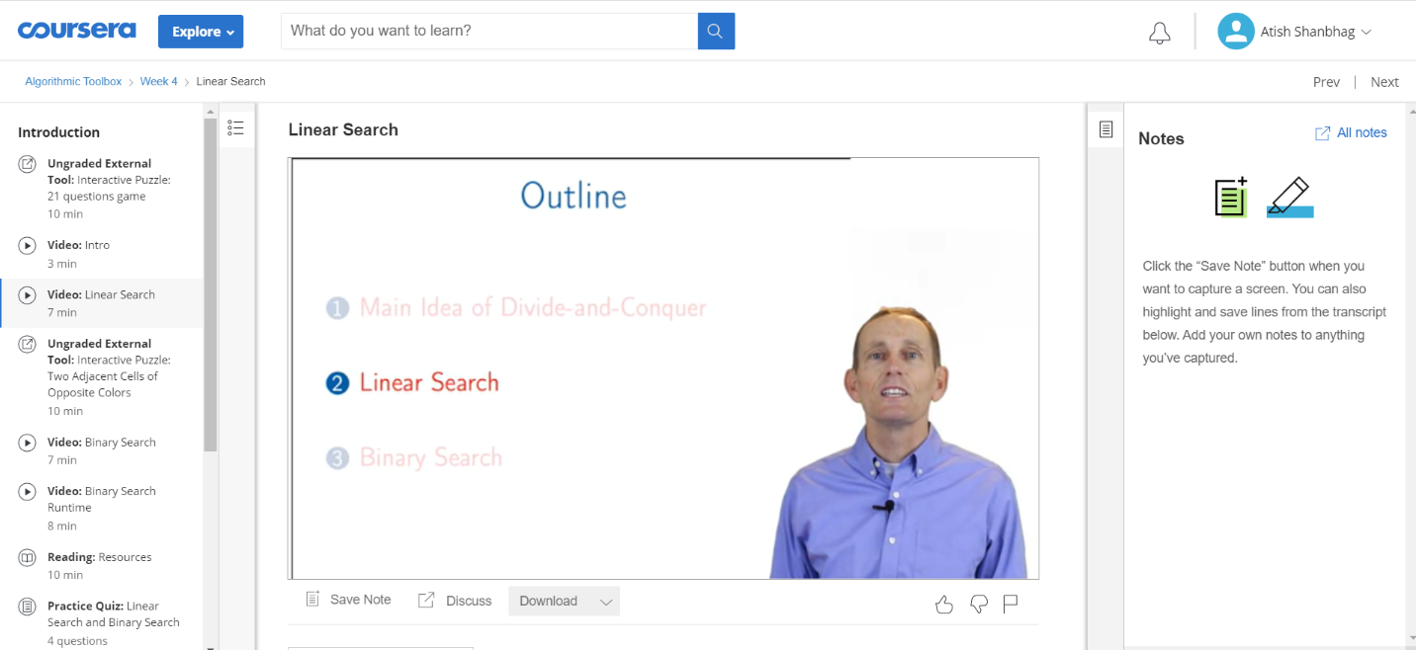

DHRUVIL:

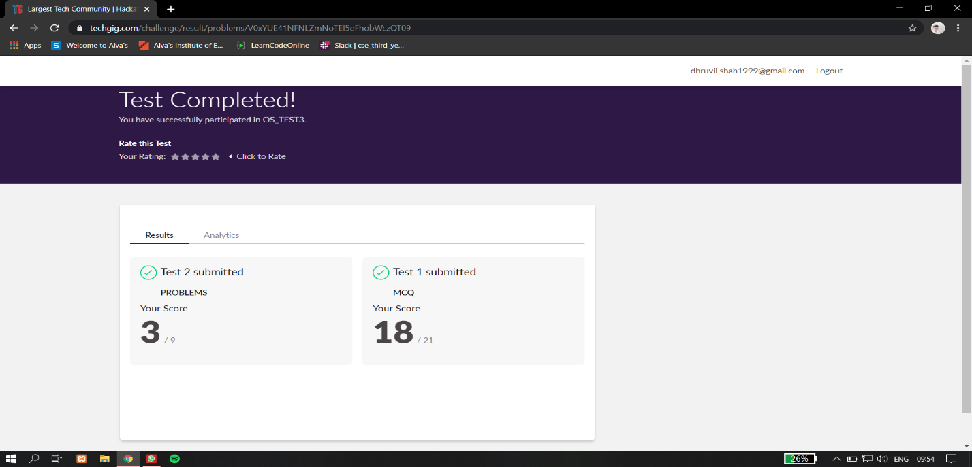

Certification Course Details:

Report

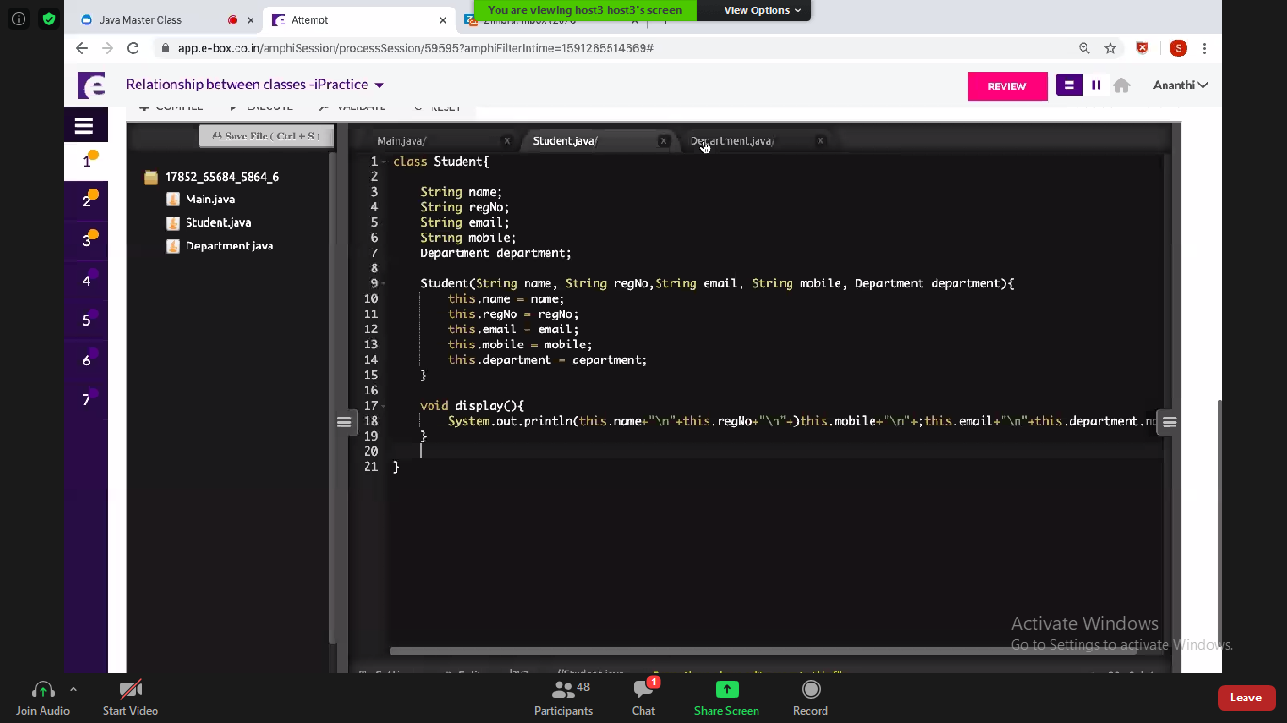

PRIYA:

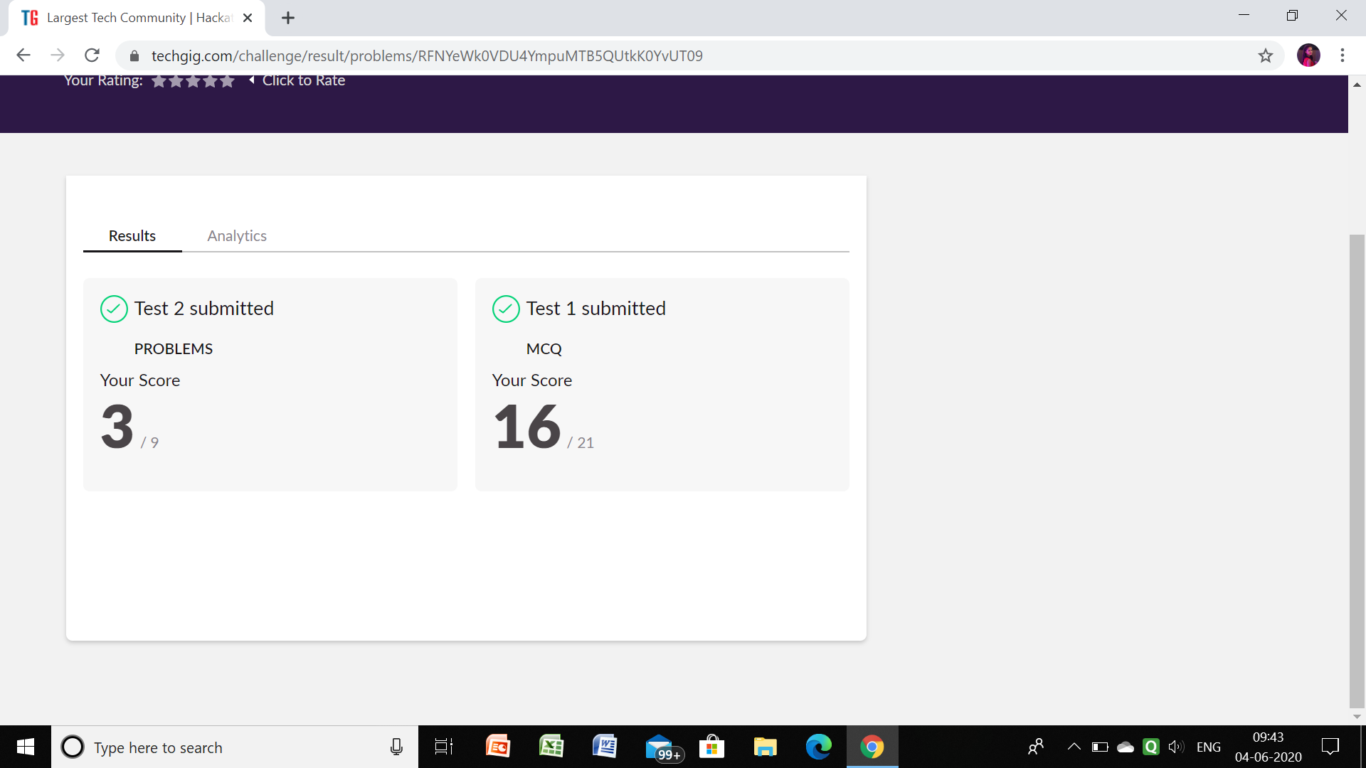

**Certification Course Details:**

Github link for information: <https://github.com/priya3028/Daily-status>

ROHAN VASISTA:

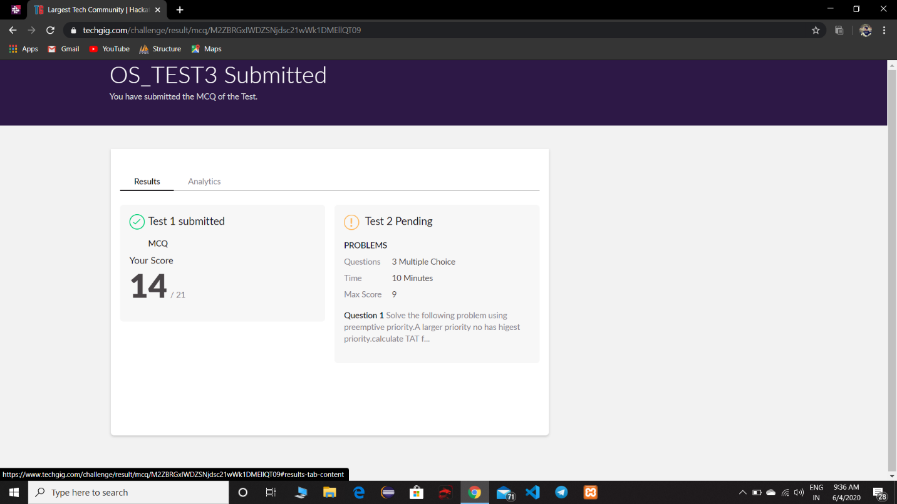

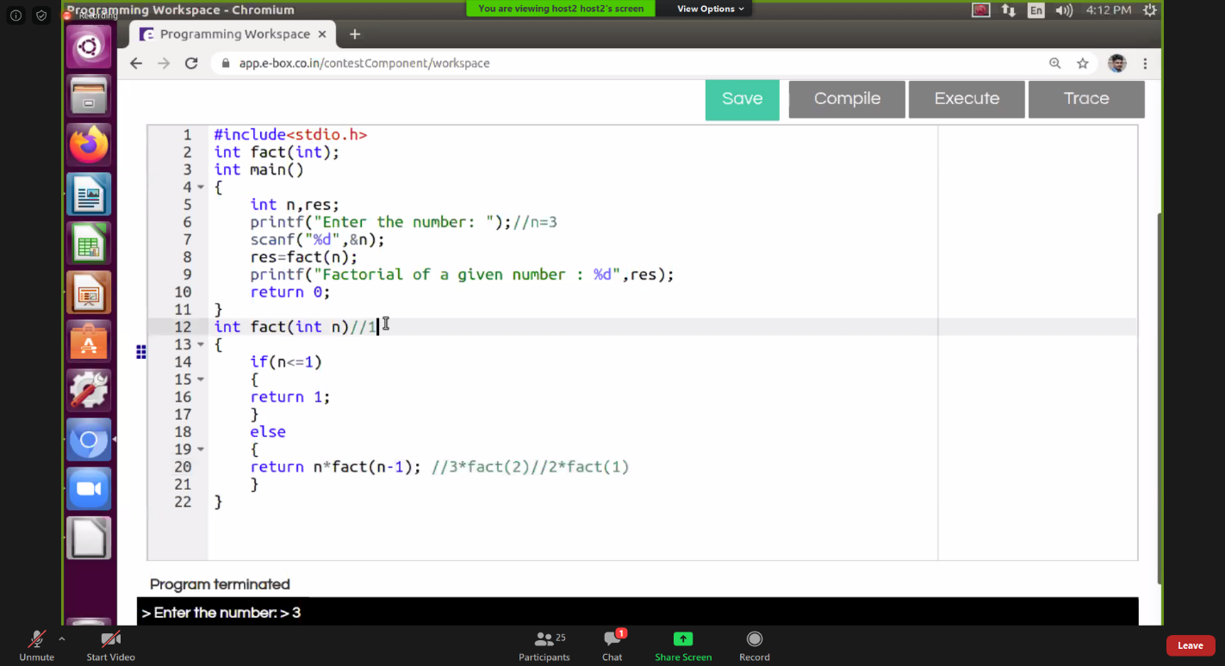

ROUSHA:

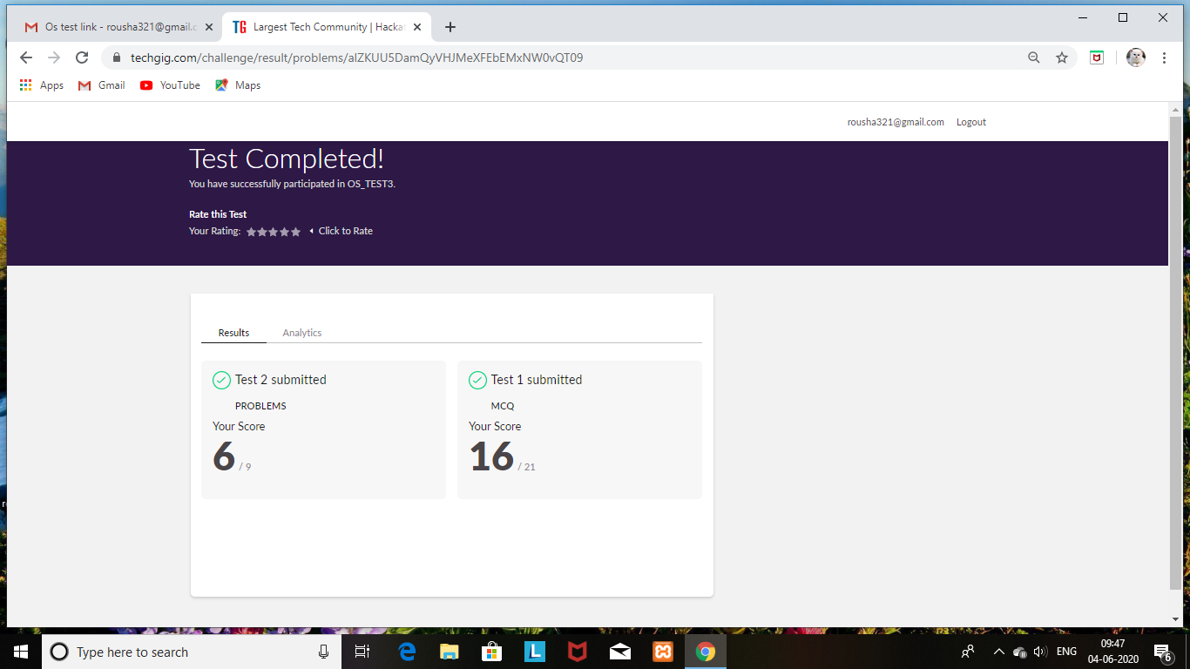

Certification Course Details: (Attach the snapshot and briefly write the report for the same)

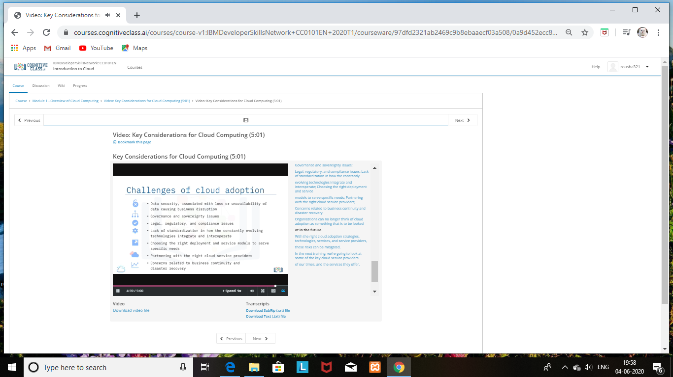

SHAIFA:

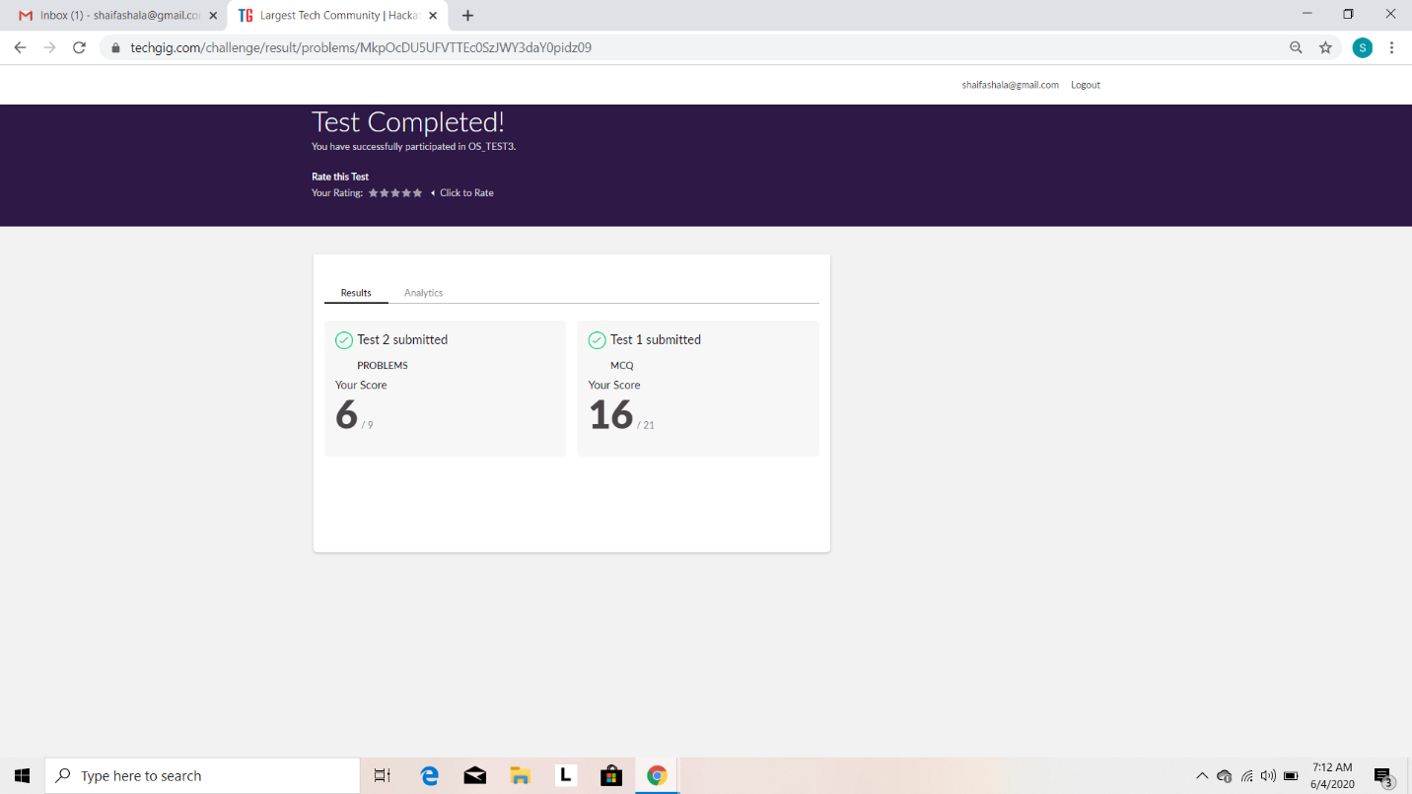

Certification Course Details: (Attach the snapshot and briefly write the report for the same)

